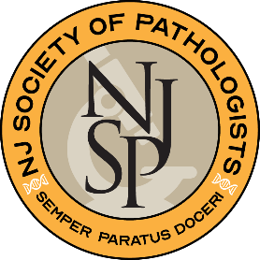
The New Jersey Society of Pathologists

September 16, 2022

Dear Pathology Resident:

We are excited to announce that The New Jersey Society of Pathologists 72nd Slide Seminar and Annual Fall Meeting will be held in person for the first time since 2019!

Date: Saturday, December 3, 2022
Time: 7:30am
Location: Forsgate Country Club, Monroe Township, NJ

As part of the program, we are inviting pathology residents to participate in the meeting and to submit an abstract for presentation. Prizes will be awarded for the top posters. The best resident poster will receive the Jonathan F. Lara Award in honor of the late Dr. Lara of Saint Barnabas Medical Center. The second-place poster will receive the Linda Bartolo Award in honor of the late NJSP Executive Director.

Abstracts are limited to 350 words and the deadline for submission is November 7, 2022. Each abstract must include the presenters’ name(s), location(s), phone number(s) and email address(es). Abstracts that have been presented at previous meetings (USCAP, ASCP, CAP, etc.) are acceptable for submission to this meeting. However, posters that have been presented at previous NJSP Fall Meetings will not be accepted. Abstracts should be formatted to include a background, methods and materials, results, and discussion. Abstracts must be submitted as a Microsoft Word file, sent as an email attachment to: Laura Abal labal@successcomgroup.com.

If you are interested in presenting a poster or have any questions, please contact Laura Abal, by phone 973-992-7800 Ext 181 or by email labal@successcomgroup.com.

Best regards,

Valerie A. Fitzhugh, MD, Billie Fyfe-Kirschner, M.D. and Rajiv Pulinthanathu, M.D.
Co-Chairs, Young Pathologists’ Division, NJSP

